**Identifying and Classifying triangles**

Triangles are shapes that you see everywhere in daily life. Cloth hangers, flags, roofs, sandwiches, pizza slices, pyramids, and prisms resemble triangles. Triangles have various characteristics that are used to classify them into various groups. In this article, let’s explore the ways we can classify triangles.

**What is a triangle?**

A polygon is a 2D shape made of straight line segments, forming a closed shape. The minimum number of straight-line segments needed to create a polygon is three, making a triangle the most basic polygon. The main features of a triangle are its three edges, three vertices, and three interior angles. Triangles can be classified into various groups based on the size of their angles and the length of their edges.

**Classifying based on sides**

We can classify triangles into three main groups by comparing the lengths of the three sides.

1. If the three sides of a triangle are equal in length, it is classified as an equilateral triangle. Equilateral triangles have three lines of symmetry.
2. If only two sides of a triangle are identical, it is classified as an isosceles triangle. Isosceles triangles have two identical angles and a single line of symmetry.
3. If none of the sides of a triangle are identical, then it is classified as a scalene triangle. A scalene triangle is not symmetrical.

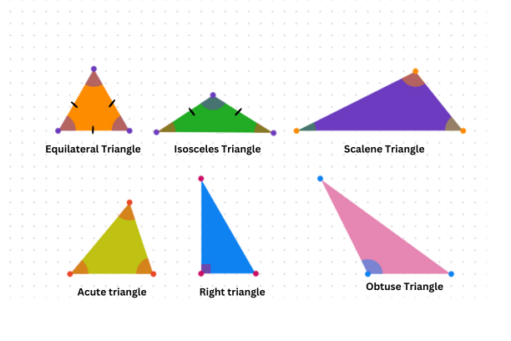

**Classifying based on angles**

The interior angles are the angles formed between each pair of legs of the triangle. By comparing the size of the interior angles we can categorize triangles as follows:

1. If the three angles of a triangle are acute, it is classified as an acute triangle. An acute angle is an angle that is less than a right angle (90o). For example, an acute triangle may consist of the following triplet of angles : 40o: 60o : 80o.
2. If one angle of a triangle is obtuse, i.e. greater than a right angle, it is classified as an obtuse triangle. For example, a triangle with interior angles 30o: 40o : 110o is an obtuse triangle.
3. If one of the angles of a triangle is a right angle (90o), it is classified as a right triangle. Right triangles have many unique characteristics described in famous theorems like the Pythagorean theorem and branches of math like trigonometry.



**Overlapping features**

Some triangles have properties that fit into more than one of the classifications we discussed. Here are a couple of examples:

1. Equilateral Triangle: A triangle with all sides equal in length. We know this is an equilateral triangle, but because all its angles are also equal (60° each), it can also be classified as an acute triangle. So, equilateral triangles are a type of acute triangle.
2. 45°-45°-90° Triangle: This triangle has a right angle, so it’s a right triangle. Additionally, the two legs are equal in length because the other two angles are both 45°. This makes it an isosceles triangle as well.

